Civil war in Georgia

UNSC Resolution: | 993
Date of adoption: | 12-May-1995
Operative paragraph: | 4
Demand number: | 993.0411

David Siroky

Wording of demand

reach substantive progress in the negotiations under the auspices of the UN and with the assistance of the Russian Federation as facilitator and with participation of representatives of the OSCE

List of addressees of the demand

Government of Georgia, Abkhazia

Short-term compliance

Description of the addressee(s)’ conduct

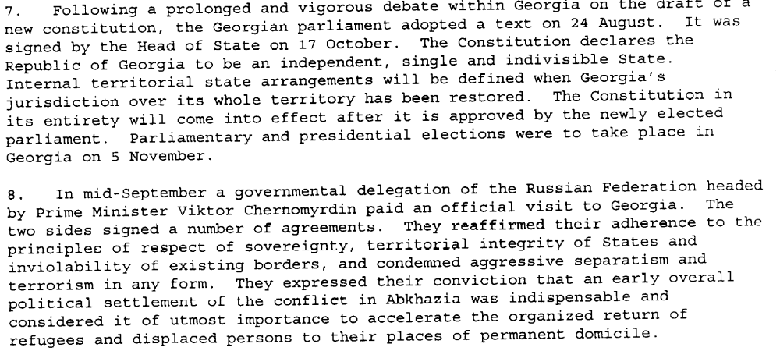S/1995/937

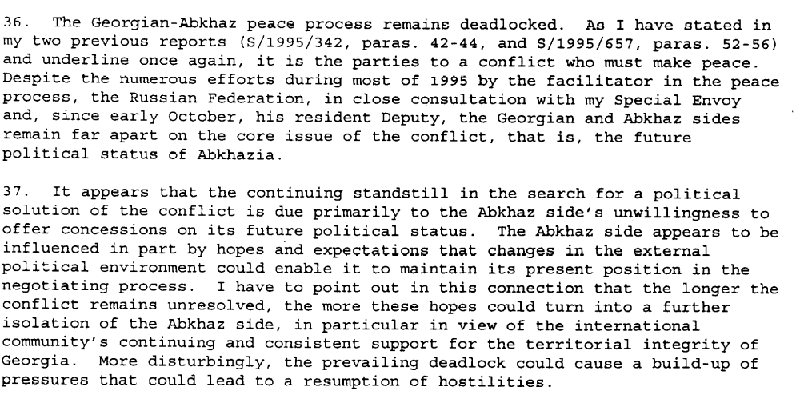S/1995/937

Assessment

Short-term compliance
No or marginal compliance (1) | Medium low compliance (2) | Medium high compliance (3) | Full or almost full compliance (4)

Considerations underlying the assessment

Medium-term compliance

Description of the addressee(s)’ conduct

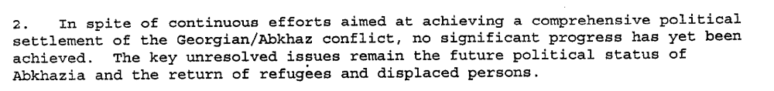s/1996/843

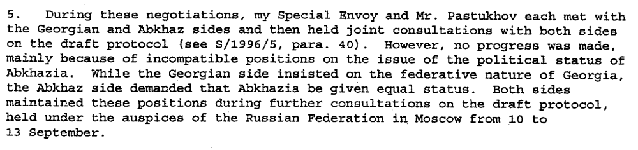s/1996/843

s/1996/843

Assessment

Medium-term compliance
No or marginal compliance (1) | Medium low compliance (2) | Medium high compliance (3) | Full or almost full compliance (4)

Considerations underlying the assessment

Depth of demand

Assessment

Level of depth of demand
Low depth of demand (1) | Medium depth of demand (2) | High depth of demand (3)

Considerations underlying the assessment

Level of confidence about coding decisions
Level of confidence about coding decision
Extremely high | High | Moderate

Comments to IPI (if any)

Civil war in Georgia

UNSC Resolution: | 993
Date of adoption: | 12-May-1995
Operative paragraph: | 5
Demand number: | 993.0511

David Siroky

Wording of demand

refrain from any unilateral actions which could complicate or hinder the political process aimed at an early and comprehensive settlement

List of addressees of the demand

Government of Georgia, Abkhazia

Short-term compliance

Description of the addressee(s)’ conduct

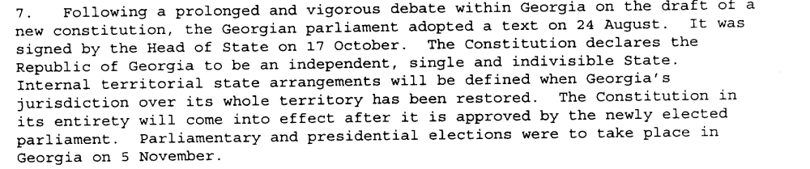s/1995/937

Assessment

Short-term compliance
No or marginal compliance (1) | Medium low compliance (2) | Medium high compliance (3) | Full or almost full compliance (4)

Considerations underlying the assessment

Medium-term compliance

Description of the addressee(s)’ conduct

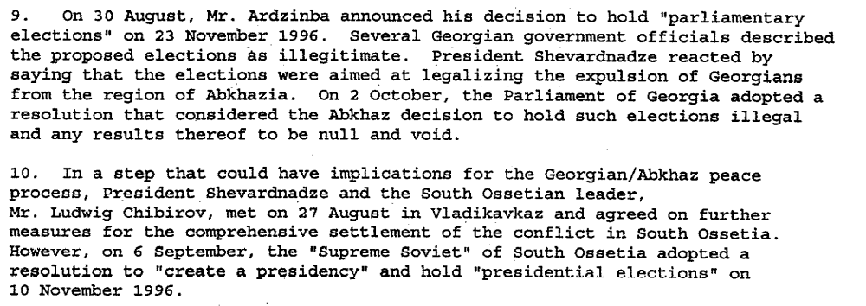s/1996/843

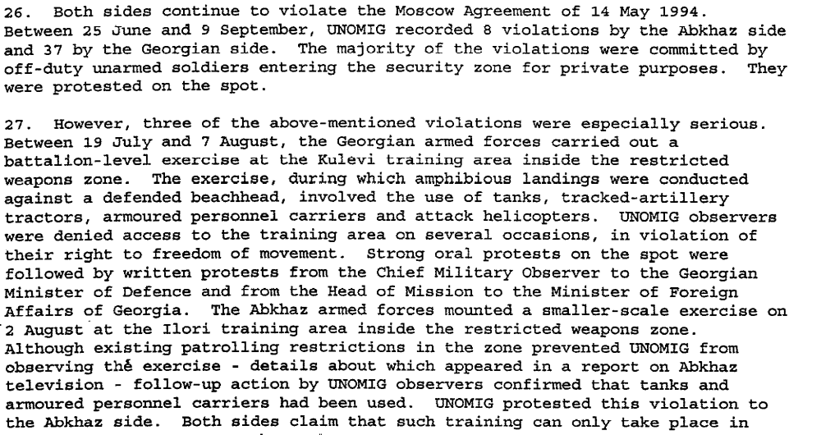
s/1996/843

Assessment

Medium-term compliance
No or marginal compliance (1) | Medium low compliance (2) | Medium high compliance (3) | Full or almost full compliance (4)

Considerations underlying the assessment

Depth of demand

Assessment

Level of depth of demand
Low depth of demand (1) | Medium depth of demand (2) | High depth of demand (3)

Considerations underlying the assessment

Level of confidence about coding decisions

Level of confidence about coding decision
Extremely high | High | Moderate

Comments to IPI (if any)

Civil war in Georgia

UNSC Resolution: | 993
Date of adoption: | 12-May-1995
Operative paragraph: | 6
Demand number: | 993.0611

David Siroky

Wording of demand
accelerate significantly the process of the voluntary return of refugees and displaced persons by accepting a timetable on the basis of that proposed by the Office of the UN High Commissioner for Refugees, and to guarantee the safety of spontaneous returnees already in the area and regularize their status in accordance with the Quadripartite Agreement

List of addressees of the demand

Government of Georgia, Abkhazia

Short-term compliance

Description of the addressee(s)’ conduct

“There has been no significant change in the situation of the displaced persons (S/1995/937, par. 10)”

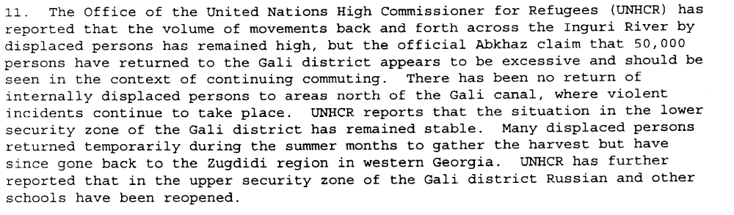S/1995/937

Assessment

Short-term compliance
No or marginal compliance (1) | Medium low compliance (2) | Medium high compliance (3) | Full or almost full compliance (4)

Considerations underlying the assessment

Medium-term compliance

Description of the addressee(s)’ conduct

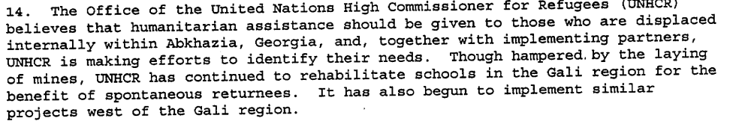s/1996/843

Assessment

Medium-term compliance
No or marginal compliance (1) | Medium low compliance (2) | Medium high compliance (3) | Full or almost full compliance (4)

Considerations underlying the assessment

Depth of demand

Assessment

Level of depth of demand
Low depth of demand (1) | Medium depth of demand (2) | High depth of demand (3)

Considerations underlying the assessment

Level of confidence about coding decisions

Level of confidence about coding decision
Extremely high | High | Moderate

Comments to IPI (if any)

Civil war in Georgia

UNSC Resolution: | 993
Date of adoption: | 12-May-1995
Operative paragraph: | 8
Demand number: | 993.0811

David Siroky

Wording of demand

improve cooperation with UNOMIG and the CIS peace-keeping force in order to provide a secure environment for the return of refugees and displaced persons and also honor commitments with regard to the security and freedom of movement of all UN and CIS personnel

List of addressees of the demand

Government of Georgia, Abkhazia

Short-term compliance

Description of the addressee(s)’ conduct

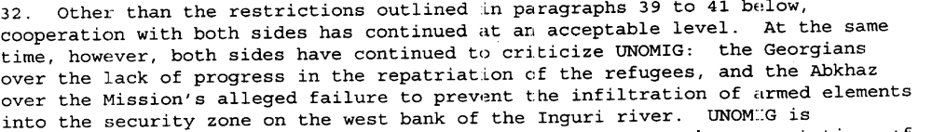s/1995/657

Assessment

Short-term compliance
No or marginal compliance (1) | Medium low compliance (2) | Medium high compliance (3) | Full or almost full compliance (4)

Considerations underlying the assessment

Medium-term compliance

Description of the addressee(s)’ conduct

s/1995/657

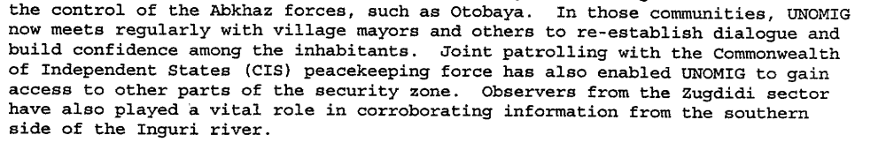s/1996/843

s/1996/843

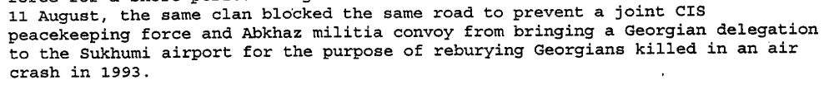

s/1996/843

Assessment

Medium-term compliance
No or marginal compliance (1) | Medium low compliance (2) | Medium high compliance (3) | Full or almost full compliance (4)

Considerations underlying the assessment

Depth of demand

Assessment

Level of depth of demand
Low depth of demand (1) | Medium depth of demand (2) | High depth of demand (3)

Considerations underlying the assessment

Level of confidence about coding decisions

Level of confidence about coding decision
Extremely high | High | Moderate

Comments to IPI (if any)

